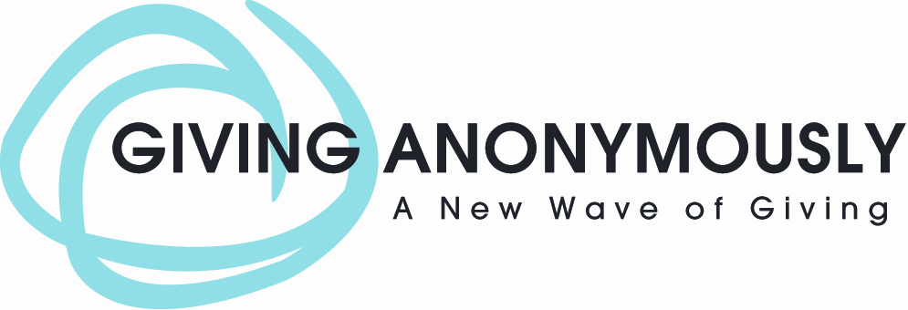

- If You are in Need
- If You are trying to help someone else in Need
- If You are a Church or Charity
- If You are raising funds for a noble cause



Then Check Out our NEW
“GIVE NOW” button



Place our button on a Blog, Facebook page or website
Start receiving gifts and donations

There is NO Monthly Fee, NO Set Up Fee, NO Transaction Fees – IT’S FREE*

__________________________________________

To Apply or for More information, contact: Info@GivingAnon.org

*In some cases, gift fees are paid for by donors’ contributions to Giving Anonymously.

